Year 11 Research Essay: USA Between the Wars

- You are to prepare an essay to write as a test in class. This essay is essentially a ‘revision’ essay prior to the exams.
- Your assessments will have been competed for semester 1 with 2 x Document Studies and 2 x Essays – to be finalised with a 2.5 hour exam.

- This essay will count for 12.5% of your marks.
- NO notes are to be used in the test; no notes are required to be handed in
- Careful planning of the essay is required to ensure you make reference to the quote

- The test will be written on the first Monday of Term 2…….9th May 2011

ESSAY:
“A change in leadership brings about a change in government attitudes, actions and expectations”
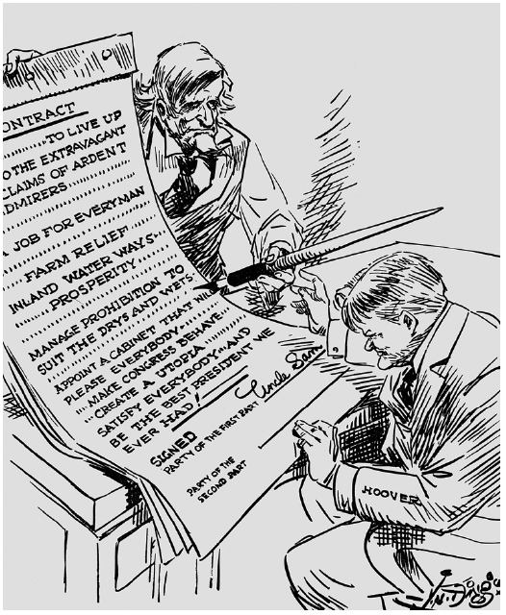
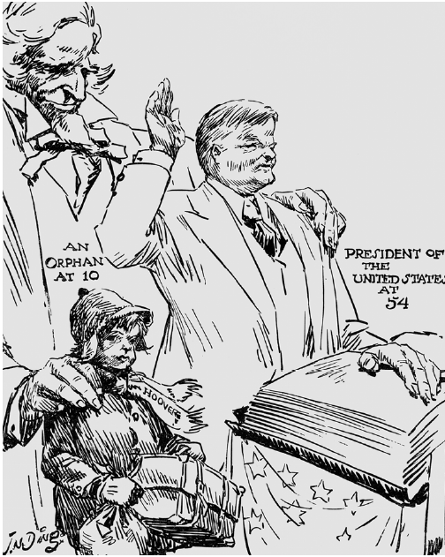
Discuss the above quote in respect to Herbert Hoover and Franklin D Roosevelt

